**WALMART SALES SQL QUERIES**

1. The total revenue generated

SELECT ROUND(sum(total), 2) AS revenue

FROM walmart_sales;



1. How many customers are there in terms of gender

select gender,

count(invoice_id)

from walmart_sales

group by gender;

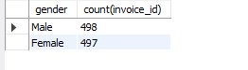

1. Revenue generated per branch

SELECT branch,

round(sum(total), 2) AS revenue

FROM walmart_sales

GROUP BY branch

ORDER BY revenue desc;

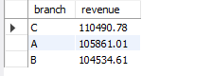

1. Revenue generated by each product line

SELECT product_line,

round(sum(total), 2) AS revenue

FROM walmart_sales

GROUP BY product_line

ORDER BY revenue desc;

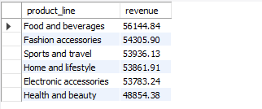

1. Number of products sold

SELECT product_line,

sum(quantity) as qty

FROM walmart_sales

GROUP BY product_line

ORDER BY qty DESC;

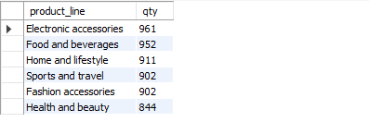

1. The different branches and where they are located

SELECT DISTINCT branch,

city

from walmart_sales;

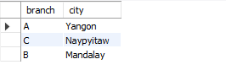

1. The most preferred payment method by customers

select payment_method,

count(1) as count

from walmart_sales

group by payment_method

order by count desc;

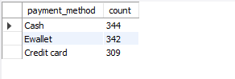

1. Percentage of revenue generated per product line

select product_line,

round(sum(total), 2) as revenue,

CAST(SUM(total) * 100 / (select sum(total) from walmart_sales) as DECIMAL(10, 2) ) as pct

from walmart_sales

group by product_line

order by revenue desc;

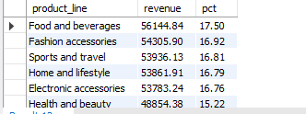

1. Display the first and the last record of the database

SELECT MIN(invoice_id) as firt_record,

MAX(invoice_id) as last_record

FROM walmart_sales;

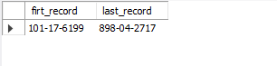

1. arange your database according to department and order by unit price

select w.invoice_id,

w.branch,

w.product_line,

w.unit_price,

ROW_NUMBER () over(PARTITION BY product_line order by unit_price desc) as rn

from walmart_sales w;

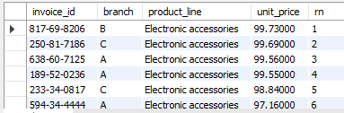

1. most sought after product line according to gender

select gender,

product_line,

count(product_line) as count

from walmart_sales

group by gender, product_line

order by count desc;

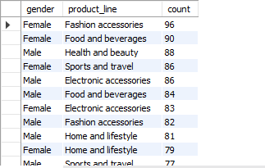

In this case fashion accessories are bought mostly by female customers…